## **Software Flow and Game States**

The game will have the following 3 game states: “Main Menu”, “Gameplay”, “Pause”, “Game Over”, and “Victory”.

1. **Main Menu**

This state will be the first state the game enters. The following buttons which leads to different states or pages are displayed to the user:

* “Play” option
* “Exit” option
* “Instructions” option
* “Settings” option
* “About” option

1. **Gameplay**

After pressing the “Play” button in the Main Menu state, the game opens the game map where the game takes place.

1. **Pause**

During the “Gameplay” state, the player can enter the “Pause” phase upon hitting the “ESC” key while playing. The gameplay is paused during this state and the game map is darkened. The following buttons are displayed to the player:

* “Resume” button: this button resumes the game and puts the game back in the “Gameplay” state
* “Exit to Main Menu”: this button puts the game back to the “Main Menu” state.
* “Exit Game”: this button terminates the program.

*[Next page]*

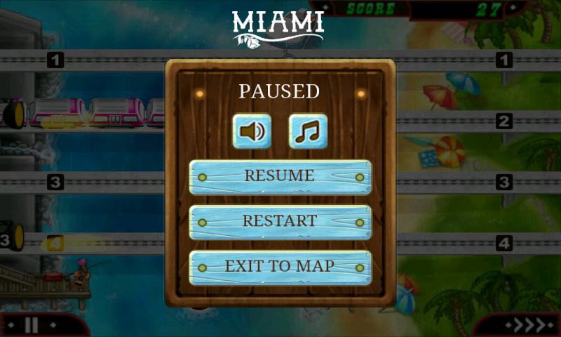

*Figure 1*: Sample of the paused state

1. **Game over**

The software enters this state when the player loses. The map is blurred out with the text “Game Over” displayed. The following buttons are shown on the screen:

* “Retry”: This puts the game back to the “Gameplay” state and restart the gameplay
* “Main Menu”: Go back to “Main menu” state
* “Exit Game”: Terminate the program

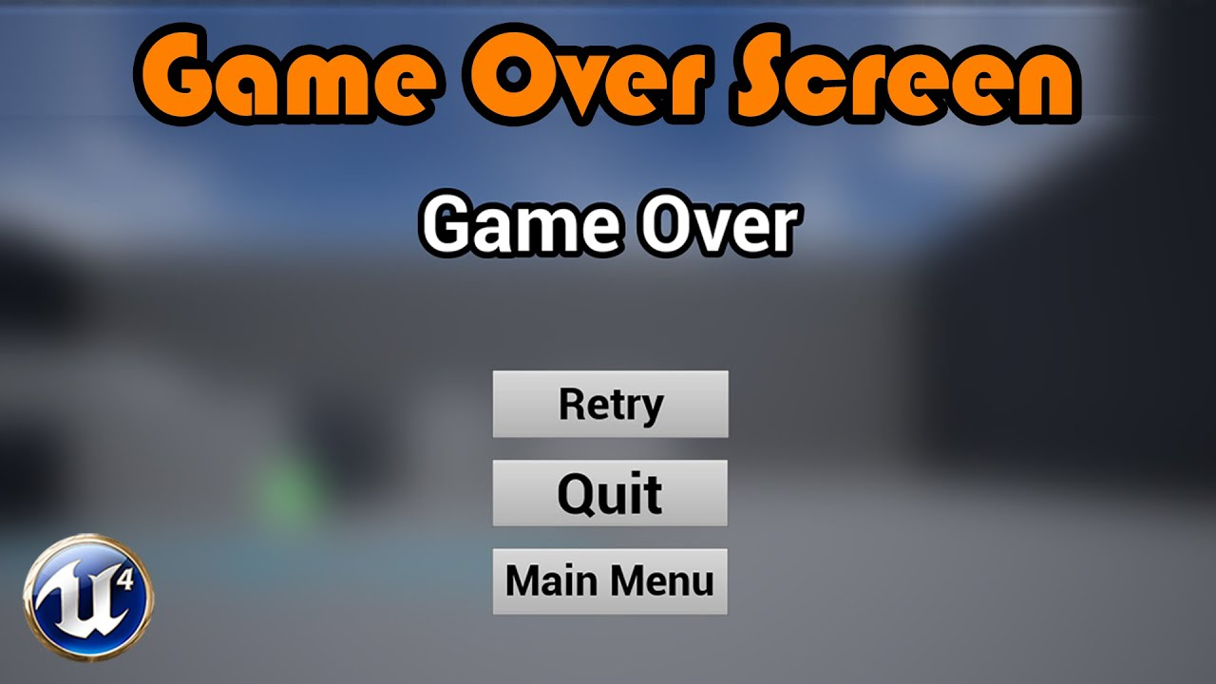

*Figure 2*: Sample of the game over state

1. **Victory**

This game state is entered when the win condition has been met. The game map is blurred and the text “Victory!” is displayed on the screen. The following buttons are also displayed.

* “Retry”: This puts the game back to the “Gameplay” state and restart the gameplay
* “Main Menu”: Go back to “Main menu” state
* “Exit Game”: Terminate the program

## **Win and Lose Conditions**

1. **Win condition:** The player has defeated all enemies. The game enters the “Victory” game state.
2. **Lose condition:** The player has run out of Health Points (HP). The game enters “Game over” game state.

## **Map Layout**

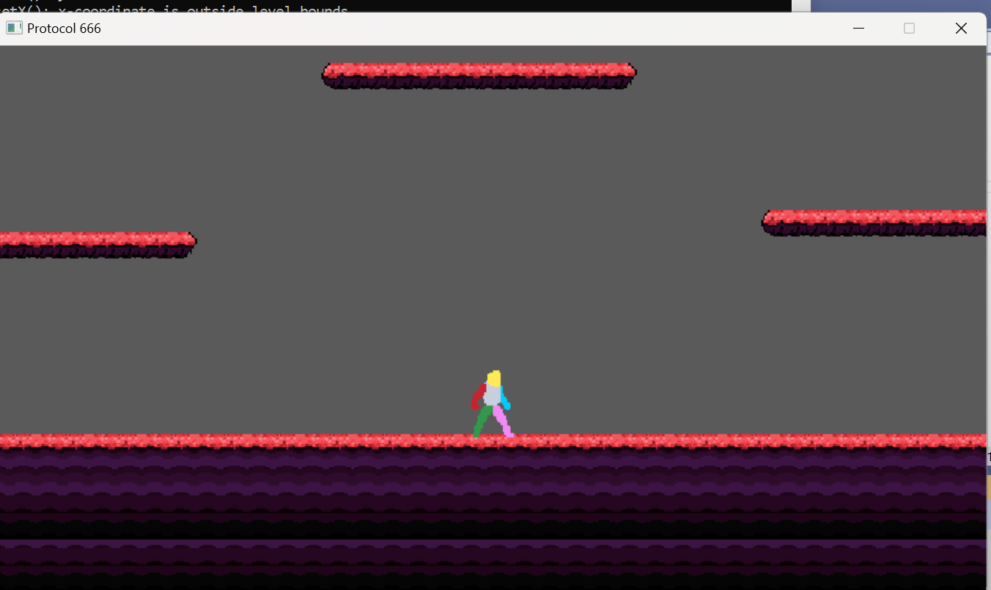

*Figure 3*: Current map layout

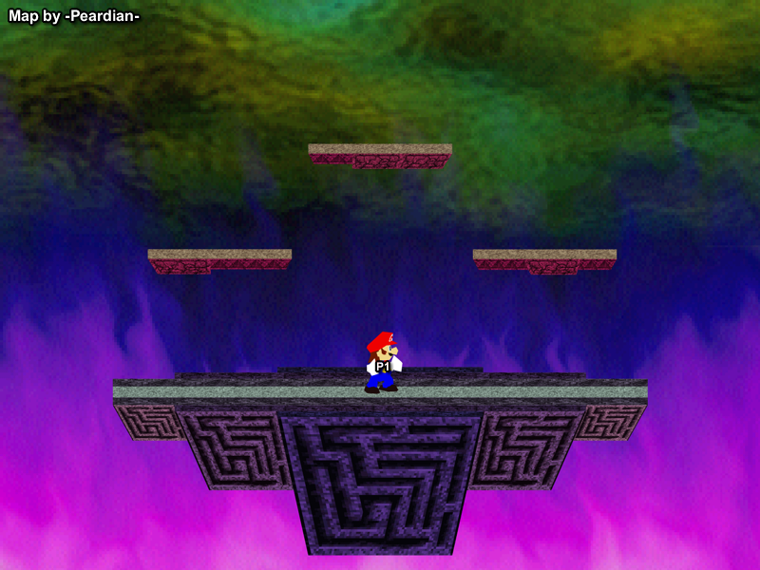

*Figure 4:* Sample map layout

**Dimensions of map**: To be decided.

The game takes place on a terrain with floating platforms all across the map. The player always begins in the center of the terrain. The map only uses 1 type of tile.

## **User Interface**

Gameplay information displayed to the user during “Gameplay” state:

* **Player’s health**: displayed on a “health bar” on the bottom left of the screen.

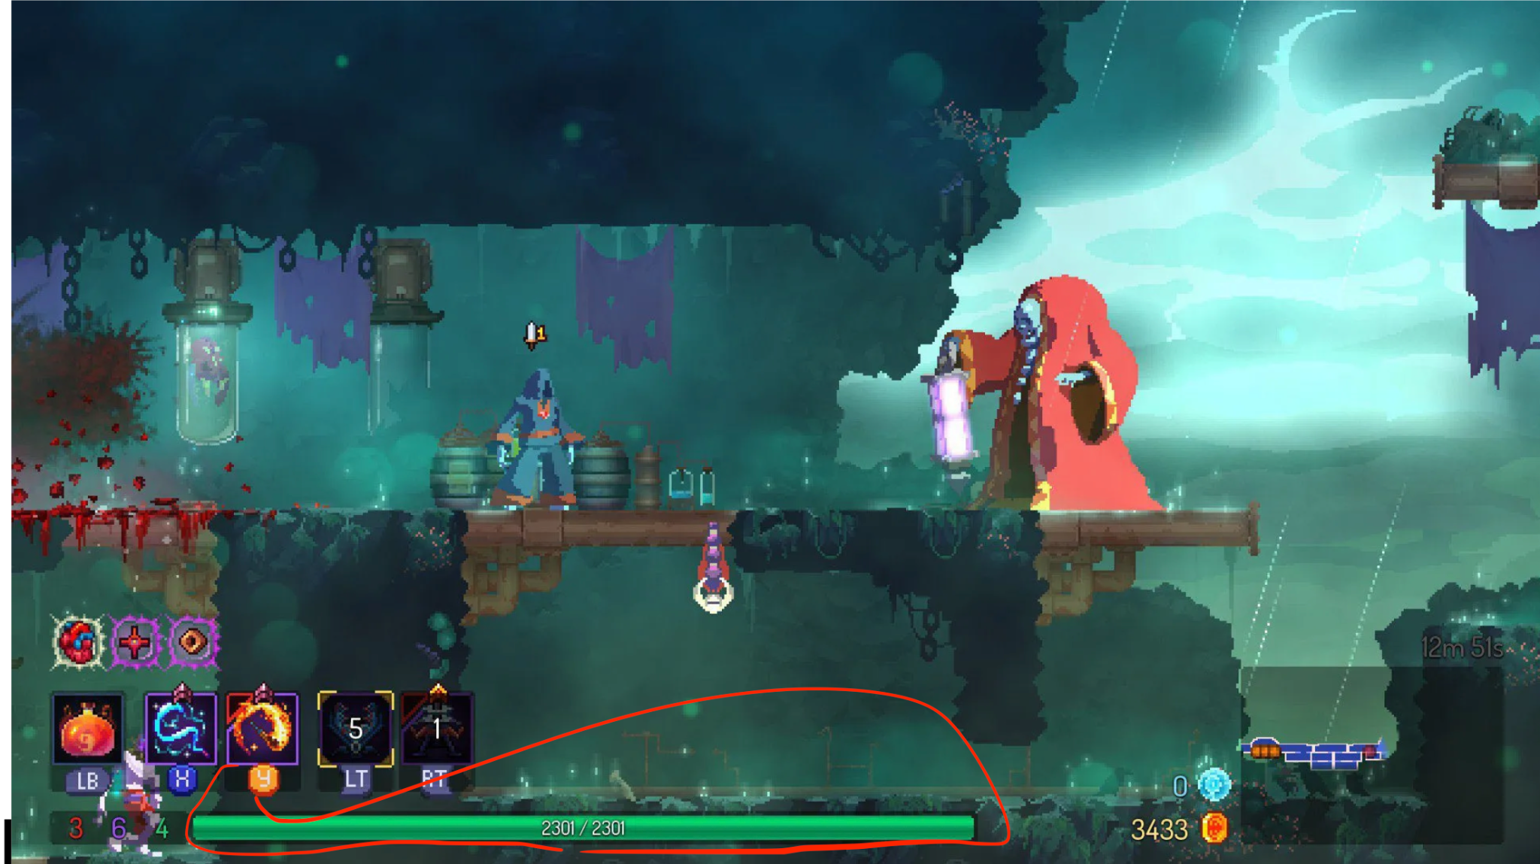

*Figure 5*: Sample health bar for Player object

* **Enemy health:** The remaining health points of enemies are only displayed when the player causes damage to the enemies. This health bar is displayed on top of the enemies health for 5 seconds. If enemy doesn’t take damage for 5 secs, the health bar disappears

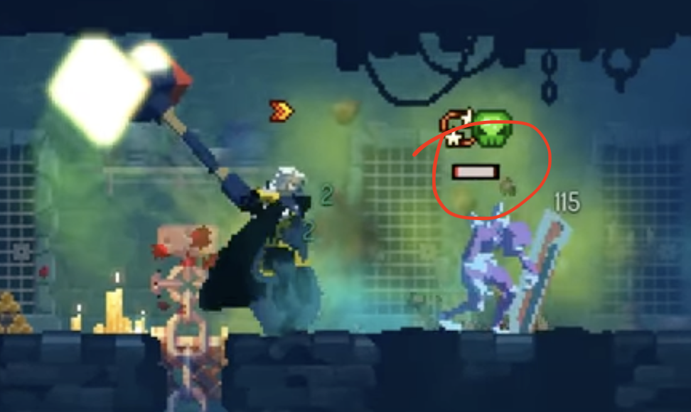

*Figure 6:* Sample health for Enemy object

## **Playable Character**

## 

*Figure 7*: Current playable character

The player can perform the following actions:

* **Run**: this is done using the left/right arrow keys and A/D keys.
* **Jump**: this is done with the up arrow and W keys.
* **Shoot**: done by holding the left mouse button. A cursor will be on the screen and projectiles will fly towards the direction of the cursor the moment the left mouse button is clicked.

## **Non-playable Characters**

### Goons

Ranged Goon

Melee Goon

Shield Goon

Kamikaze Goon

Sniper Goon

### Boss

### Final notes: